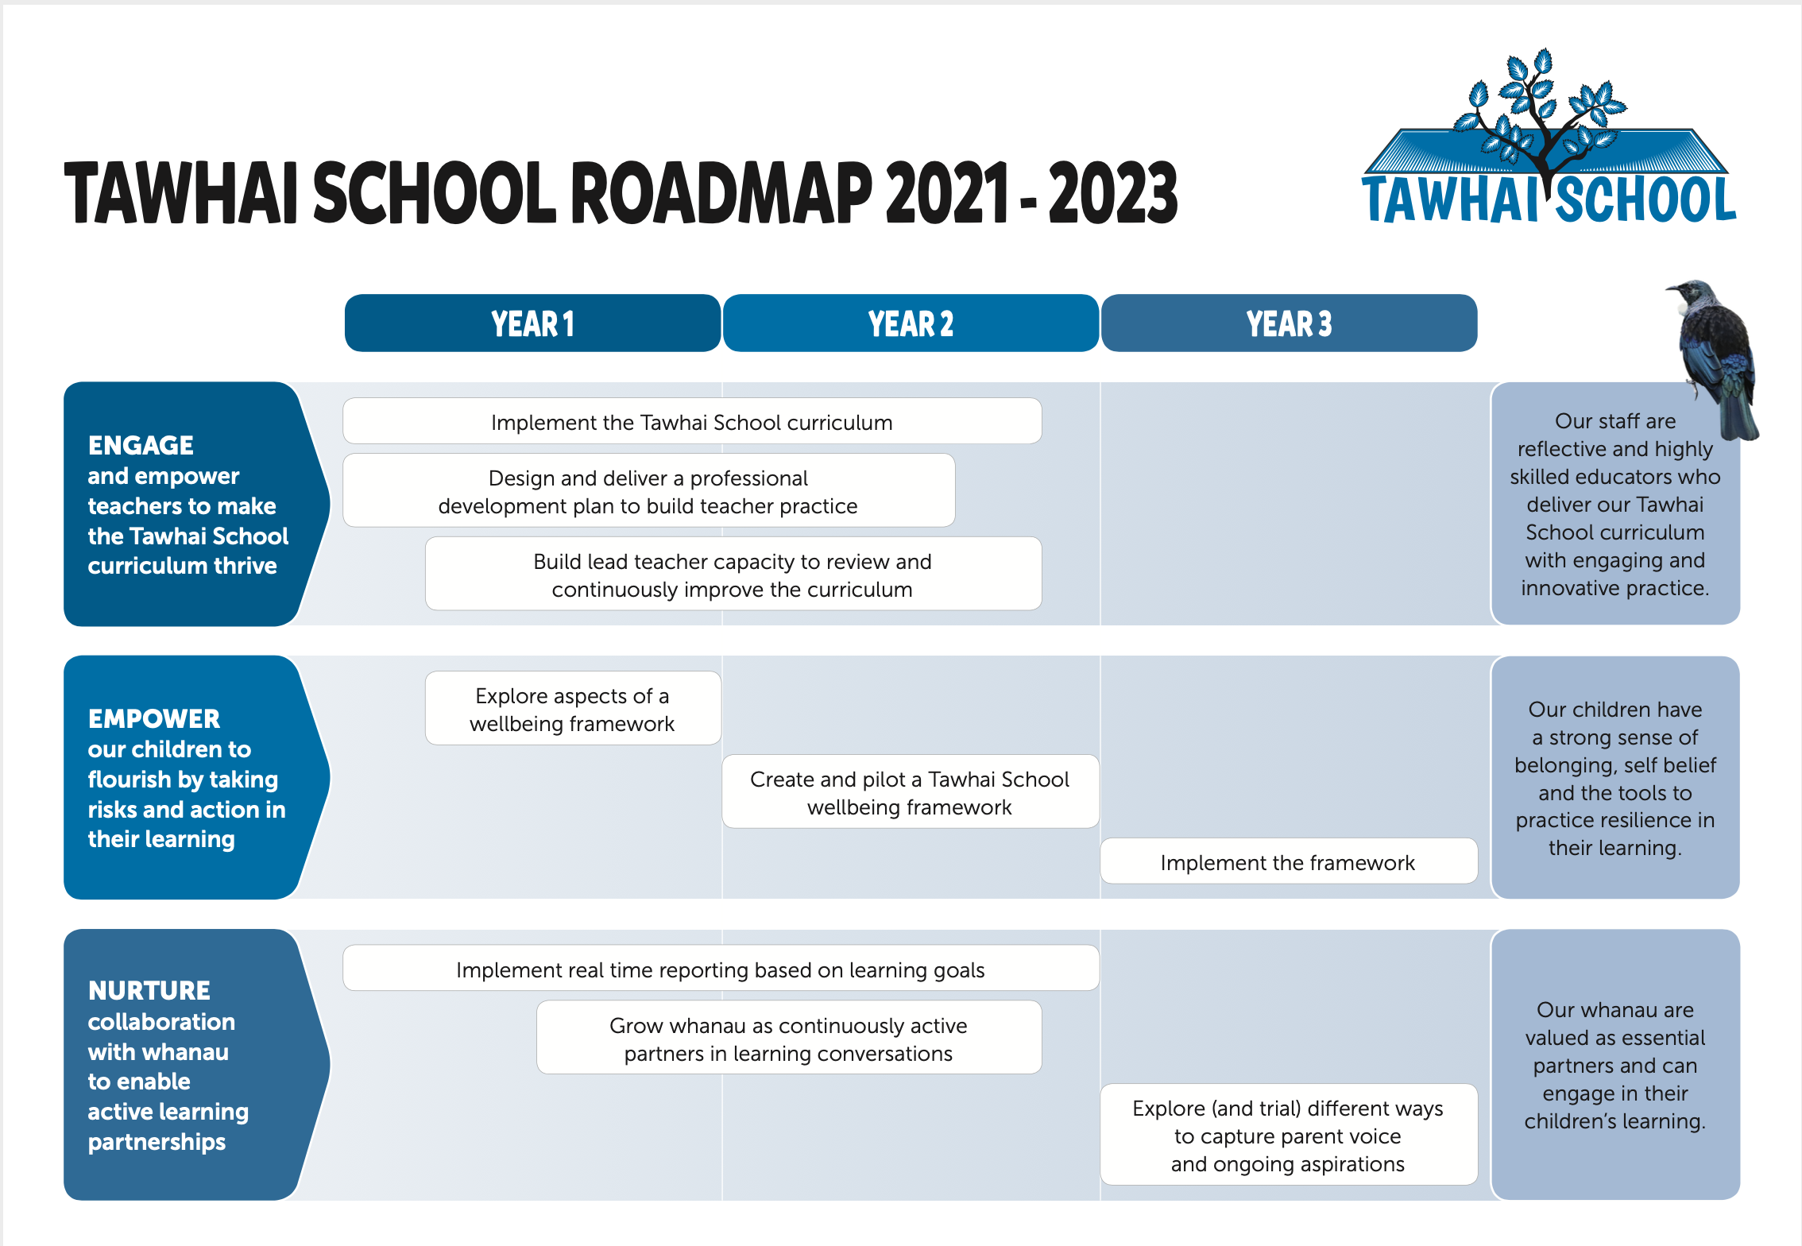
Annual Plan 2023
2021 2022 2023

ERO FOCUS: To raise Māori engagement and achievement, through building positive relationships and raising cultural awareness within the school.
Attendance target in response to Attendance and Engagement Strategy  Initiatives | 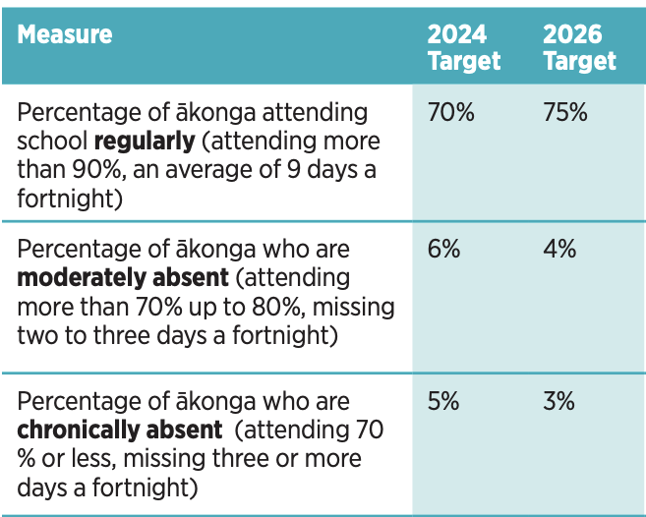  Baseline data and targets:  Regular Attendance as outlined by the MOE is a child attending school more than 90%,  an average of 9 days a fortnight.  In Term 4 of 2022 attendance rates for cohorts of concern were:  - Māori cohort - 69.6%regularly attending  - Pacific cohort - 64.3% regularly attending  - Asian cohort - 46.3% regularly attending  - Year 5 - 43% regularly attending  Targets for 2023:  - To increase regular attendance for our Māori cohort to 75%  - To increase regular attendance for our Pacific cohort to 70%  - To increase regular attendance for our Asian cohort to 60%  - To increase regular attendance for our Year 6 cohort to 60%
 | Action | Who | Resources | Time | Outcomes
 | - Review and discuss termly using Everyday Matters Reports with DP/AP/P and LSC  - Attendance flowchart is reshared with teachers  - DP/P will monitor, record and share with hub leaders the chronically absent students weekly (attending 70% or less)  - Hub hui will include discussion about attendance concerns | P/ DP/AP  P/DP  Teachers | Everyday matter reports | Term 1-4 | Increased number of children present, participating and progressing.
Strategic goal | Empower our children to flourish by taking risks and action in their learning - WHAT’S NEW IN 2023?
Initiatives | Action | Who | Resources | Time | Outcomes
2C:  Implement the HAUORA framework  Measures:  - attendance target  - Participation in restorative circles (increase in number from term 1 - 4)  NELP -  Learners at the Centre  Barrier free access  Quality teaching and leadership | - Review draft Hauora Framework at teacher prep days  - Each lead teacher will make explicit connections with their lead areas and the framework.  - Teachers will be invited to give feedback on the draft visual representations. | Lead teachers | Draft visuals | Week 1 | Teachers will have a deeper understanding of aspects of our Hauora framework and a final draft will be decided.
 | - Previous LSC to present Trauma workshop at teacher preparation day. | LSC |  | Week 1 | Teachers will be reminded of Trauma informed practices.
 | - Room tours - each staff hui we will visit a classroom to see what reflects our framework | Teachers | Schedule |  | Teachers will be able to see how other teachers are reflecting the framework in their classrooms.
 | - Planning - during hub planning team leaders will facilitate discussions with the lens on our framework to support and challenge teachers to ensure aspects are reflected in planning. | Team leaders  Teachers |  | Term 1-4 | Hauora framework will be evident in planning.
 | - Lead teachers will facilitate a workshop at each staff hui  - Restorative  - PB4L  - Te Whare Tapa Wha  - Cultural Practices  - Inquiry | Lead teachers |  | Term 1-4 | Ongoing PD will support the framework to become embedded.
 | - Hauora Framework will be a standing item on the SLT agenda. |  |  |  | Aspects of framework will be under continuous review.
 | - LSC and SENCO roles will be clearly defined and included in the framework. | LSC/SENCO/SLT |  | Term 1 | Clarification of roles - teachers/whānau will know who to go to for support.
 | - SLT professional reading Niho Taniwha  - Reading responses will be discussed and followed up with actions that may include  - Conversations at hub hui  - Challenging current practice  - Share readings with teachers  - Changes in framework | SLT | Niho Taniwha texts |  | Leaders will have explored “an evidence-based and practice informed Māori pedagogical model, ākonga and whānau stories and perspectives, self-assessment tools, reflective questions, Treaty relationships and Māori perspectives on neuro diversity.”
 | - Principal to complete research and write her sabbatical report.  - Findings will be shared with SLT, staff and school board  - SLT and principal will include relevant findings in the framework. | Principal |  | Term 2/3 | Principal sabbatical report will help to further enhance our Hauora Framework by including findings on effective strategies to support trauma affected and neurodiverse ākonga.
Strategic goal | Nurture collaboration with whanau to enable active learning partnerships - WHAT’S NEW IN 2023?
Initiatives | Key Actions | Who | Resources | Time | Outcomes
3C:  Explore and trial different ways to capture parent voice and aspirations.  Measures: increased number of participants in electronic survey from 2020 | - Local curriculum expo - have a video booth with students (and prepared questions in response to our LC) to interview parents. Everyone who interviews gets a raffle ticket. | Principal  Students  Whānau | Raffle prizes | Week 3 | Levels of Māori engagement and achievement will be raised, through fostering positive relationships across  the school, building cultural capability and deepening learning-based partnerships with whānau
 | - Mutukaroa learning conversations will be facilitated by classroom teachers with the following time frames:  - As close to entry to school  - After 20 weeks at school  - After 40 weeks at school | Teachers  Whānau | Release time | Term 1-4
 | - Principal to support teachers with framework of learning conversations- this will include a google doc form that captures parent voice/aspirations. | Principal  Teachers |  | Term 1 | Learning conversations will be facilitated consistently.
 | - 20 and 40 week data will be collated to inform intervention programmes. | Y1/2 teachers  Reading Rec |  | Term 1-4 | Intervention programmes will support selected ākonga.
 | - Cultural team to co-construct and seek feedback on our tikanga in relation to mihi whakatau (already underway) and poroporoaki. These will be documented. | Cultural team |  | Term 1 | Staff have a shared understanding of our tikanga
 | - A whānau group will be reestablished to support engagement and achievement for Māori ākonga. An invitation will be extended to join the whānau group at whānau picnic. This group will then be gathered prior to the end of term 1. | Lead teacher |  | Term 1 | The Whānau group will be underway.
 | - Celebrations of learning will be held in Terms 2 and 3. These will be planned to align with current programmes. | Teachers  Whānau |  | Term 2/3 | An opportunity will be provided for whānau to celebrate and share the learning process.
 | - New 2024 Strategic Plan  - Focus parent group for SWOT and Pestle analysis tools (these will also be completed by staff and school board).  - Electronic parent questionnaire  - Paper questionnaire  - Voice will be collated and a strategic plan, aligned to new MOE guidelines will be drafted. | Principal  Board  Staff  Whānau  ākonga | Surveys | Term 3 | Voice from all stakeholders will help inform our new strategic direction for 2024.
Business as usual……………….
3A: Implement real time reporting based on learning goals  . | - Review real time reporting schedule will be co-constructed by SLT.  - A consistent approach will be established and agreed upon by the SLT for supporting teachers to meet Educa deadlines.  - Team leaders will explore examples of learning stories at hub hui - teachers will share examples to moderate.  - Parents will be supported to respond to the learning stories. Teachers will show parents during the first hui how to respond to learning stories. | SLT/Lynley  SLT  Team leaders  Teachers  Teachers/ whānau |  | Term 1  Term 1  Term 1,2,3,4  Term 1 | Teachers will be well supported to write meaningful and timely learning stories that relate to goals.  Parents will get relevant updates on their child's learning and develop a better understanding of real time reporting and feel confident to comment on updates.
3B: Grow whanau as continuously active partners in learning conversations | - Our Connections Wall - ensure whānau’s correct whakapapa is reflected on our wall. At goal setting meetings teachers will clarify this.  - Empower parents to support their children by providing opportunities for them to learn about our programmes and how they can support their children at home through learning conversations, expo, celebrations of learning. The Reading Together programme will be explored.  - Parents will be invited to attend learning conversations in Term 1 and 3 to co-construct learning goals.  - Review how many parents are commenting on the goal updates. | Teachers  SLT  Teachers  Whānau | Learning Conversation time scheduled | Ongoing | Levels of Māori engagement and achievement will be raised, through fostering positive relationships across  the school, building cultural capability and deepening learning-based partnerships with whānau  Parents feel more confident about strategies, vocab etc
Strategic goal | 1. Engage and empower the teachers to make the Tawhai School Curriculum thrive - business as usual…………
Initiative | Key Actions | Who | Resources | Time | Outcomes
1A: Implement the Tawhai School Curriculum | - Teachers work collaboratively in curriculum teams to explore our whakatauki, Poipoia te kakano kia puawai and connect with our local curriculum to develop a yearly overview.  - Teachers will co construct a presentation to share at our expo. (This evening will be combined with a meet the teacher whānau picnic).  - Team leaders allow time to explore ideas and plan at hub hui, making connections to LC and whakatauki and also ensuring coverage of yearly overview. SLT hui will allow time to formulate shared agenda for hub hui to ensure consistency. | Curriculum leads Teachers  Whanau | Teacher preparation day  Raffle prizes  Student reps  Feedback boxes | Term 1  Week 1  Week 3 | Teachers build confidence while revisiting the local curriculum documentation  Parents will become familiar with aspects of our Local Curriculum.  Staff collaboratively develop programmes that are engaging for all ākonga and aligned to year overview. Team minutes will show evidence of these conversations.
1B:  Design and deliver a professional development plan to build teacher practice  Measures: Tawhai te reo stocktake will show evidence of teacher shift.  Measures: Poutama Reo rubric will evidence a shift to the right. | - An annual outline for PD is formulated to develop the key pedagogies reflected in our curriculum.  Continued development of culturally sustaining practices includes:  - MAC  - Kura Ahurea  - Tawhai te reo Māori progressions - teachers will be supported to integrate into classroom programmes  - Hauora framework - internal workshops led by SLT  Deep Learning pedagogies includes:  - Professional development in writing with Verity Short (Year’s 2-6)  - Mathematics (Rob Profitt - supported by Maths lead teacher)  - Integrated inquiry support (internal - supported by NPDL lead teacher)  Restorative Practices/PB4L/Alert (some external and internal support by PB4L lead teacher).  PCT/ AP/DP TERMLY workshops (UHC) | Senior Leader-  ship Team  Teachers |  | Term 1  Week 2  T1 -4 | Teachers will be provided with a PD framework for the year.  Levels of Māori engagement and achievement will be raised, through fostering positive relationships across the school, building cultural capability and deepening learning-based partnerships with whānau  Teacher Capability is Increased by engaging in all Professional Development and teacher led staff meeting sessions.  Lead Teachers capability is enhanced by engaging in workshops/hui and facilitating the teacher led staff meetings.
1C: Build lead teacher capacity to review and continuously improve the curriculum | - The Principal and Literacy leader will support PACT to be administered in writing.  - Assessment schedules will be reviewed  - Assessments will be administered and 2023 learning targets will be set.  - Action plans for learning will be formulated by AP/DP alongside team leaders - strategies will be explored to meet targets, “what do we need to do differently?”  - Learning targets will be monitored by AP/DP, teachers will be providing data. | P/DP  P/AP/DP  Teachers  AP/DP/  Teachers  AP/DP | Staff meeting time  Review template | Week 1/2 term 1  Term 1 | Learning targets will be based on standardised assessments.  Everyone will have a shared understanding of the action plans and take shared responsibility for implementing them.
 | - Curriculum teams  - Consider student voices in their discussions by liaising with Tu Rangatira rōpū  - Formulate termly goals.  - Review goals at the end of each term.  - Draft budgets for the following year developed based on future needs/requirements.  - Provide individual support for teachers (linked to TAI)  - Collaborate across teams where appropriate | Lead teachers  Teachers |  | Term 1-4 | Curriculum teams are working and action plans reviewed.
 | - School Board reviews will be presented reflecting Evaluation indicators  - Progress on learning targets will be shared with the school board with a lens on Māori achievement.  - Schedule of curriculum reviews revised with board chair and shared with curriculum teams.  - Evaluation indicators selected by the team.  - Team presents a review to the school board according to schedule.  - Curriculum teams share reviews at staff meetings. | Principal  Lead teachers | Time  Evaluation Indicators | Term 1-4 | School board is informed of curriculum against evaluation indicators

